Microsoft SQL Server 2005 Report Pack for Internet Information Services (IIS)
The Microsoft SQL Server Report Pack for Internet Information Services (IIS) is a set of predefined report definition files that work with a sample database of information extracted from Microsoft Internet Information Services log files. This database can be populated with your own data using the Log Parser included with the IIS 6.0 Resource Kit. You can use also the sample reports as templates for designing new reports. The following table describes the sample reports that are provided in this report pack.
Report (click for image) | Description
Global Statistics | Shows a chart of web site activity grouped by the number of visitors and bandwidth for one or more sites. You can drill through on the chart to a monthly web site summary.
Site Summary | Shows web site summary statistics grouped by time period, visitors and pages and allows you to compare monthly changes in site activity. Includes a document map and all other site details. You can filter by month, year and server.
Pages | Shows a table and chart that shows the top 5 pages per site based on the number of visits and bandwidth.
Time Period | Consists of sub reports showing web site time statistics (by Day of Week, Hour of Day, and Day of Month).
Day of Week | Shows a bubble chart, bar graphs and table of web site activity grouped by day of the week and includes number of visitors, page views, page hits, and bandwidth details.
Hourly Statistics | Shows a chart and table of web site activity grouped by number of visitors, page views, bytes transferred for each hour of the day.
Day of Month | Shows a chart and table of web site activity grouped by number of visitors, page views, page hits, and bytes transferred for each day of the month.
Visitors | Consists of sub reports of web site visitor statistics grouped by time and date.
OS Statistics | Shows a table and chart of web site activity grouped by number of visits based on the type of operating system. You can drill down to web site details for each operating system.
Browser Statistics | Shows a table of web site activity grouped the number of visits based on the browser type. With drill down, you can view the version information for each type of browser on a daily basis.
Country Statistics | Shows a table and pie chart of web site activity grouped by the number of visits based on the country / region of origin.
Length Statistics | Shows a table and chart of web site activity grouped by the number of visits based on the amount of time spent on the site.

System Requirements
Your system must meet the following requirements to use the sample reports.
Server
· Microsoft SQL Server™ 2005 with the IISLOG SQL Server database installed (for IIS Report Pack reports)
· Microsoft SQL Server™ 2005 Reporting Services
Client
· Microsoft Internet Explorer 5.5 or later
· Microsoft Visual Studio® 2005 with Report Designer installed (for uploading or modifying the reports)
Disk Space
· IISLog Sample Database: 18 megabytes (MB)
· Sample Reports: 700 kilobytes (KB)

Installing the Microsoft SQL Server IIS Report Pack
- Launch SQL2005RPIIS.MSI and install the contents to a destination of your choice.
- Attach the database and upload the reports as described in the following sections.
Attaching the IIS Sample Database
- Open SQL Server Management Studio. On the Start menu, point to All Programs, point to Microsoft SQL Server 2005, and click on SQL Server Management Studio.
- Connect to the SQL Server where you want to install the sample database.
- Navigate to the Databases folder.
- Right-click the Databases folder, click Attach….
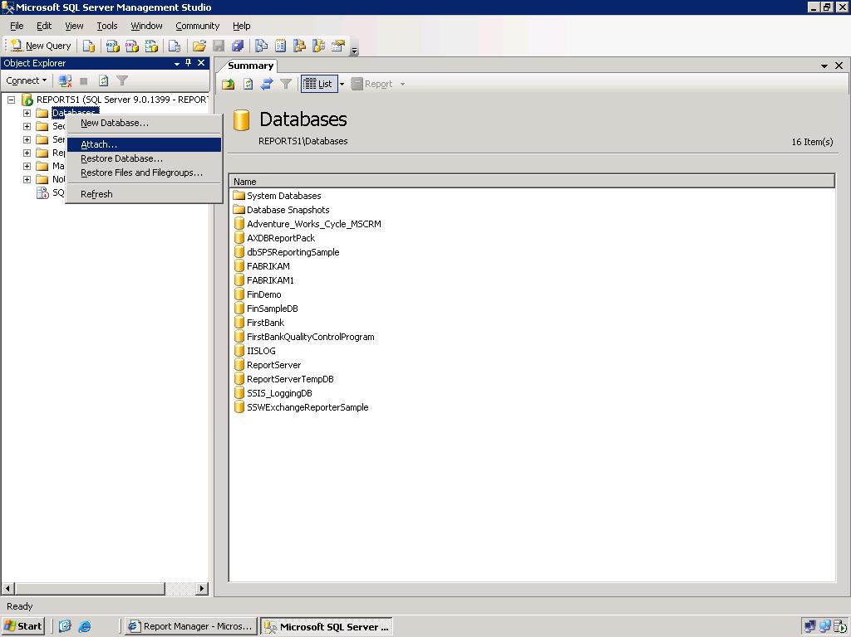

- In the Attach Databases window, click the Add button, navigate to the folder that contains the report pack files, and select the IISLOG.mdf file. Then, click OK.
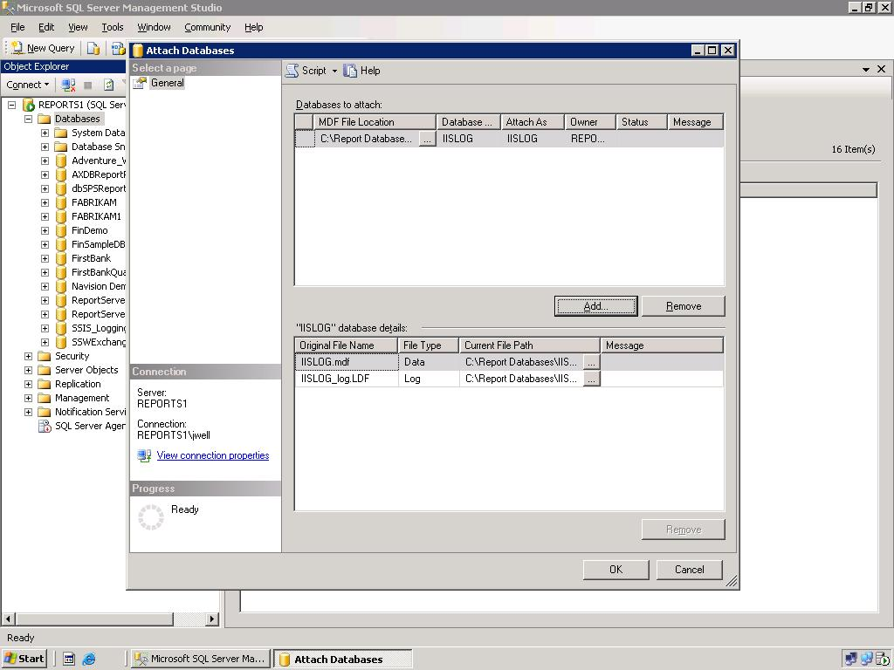

Uploading the Sample Reports
To make the sample reports available for viewing in a Web browser, you must upload the report definition files to the report server using Report Manager or Report Designer in Business Intelligence Development Studio.
Option 1: Publish sample reports using Report Designer
- Open SQL Server Business Intelligence Development Studio. On the Start menu, point to All Programs, point to Microsoft SQL Server 2005, and click on SQL Server Business Intelligence Development Studio.
- Click on File and select Open Project. Navigate to the folder where the Report pack contents have been extracted. Open the sample report project.
- By default, the reports will be published to a local report server at the URL http://localhost/reportserver. If you would like to change this location you can do this by selecting Properties from the Project menu.

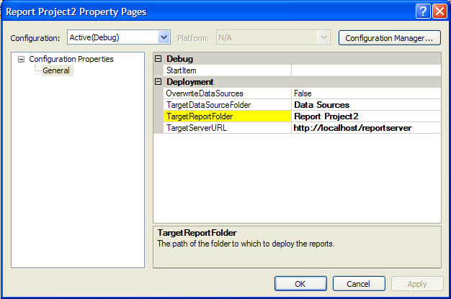

- Publish the reports by clicking Deploy IISReports from the Build menu.

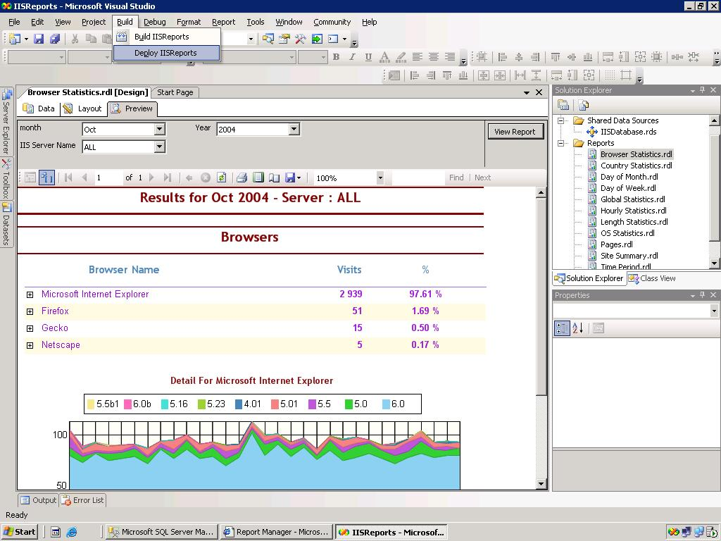

Option 2: Upload sample reports using Report Manager
Note: To create a data source and upload files to a folder on the report server, you must have permissions to manage reports for the folder. For more information, see Managing My Reports .
- Navigate to Report Manager in your browser. By default, the URL is http://<webservername>/reports.
- Create or Navigate to the destination folder for uploaded reports. For more information, see Navigating Folders in Report Manager .
- Click New Data Source, and then do the following:

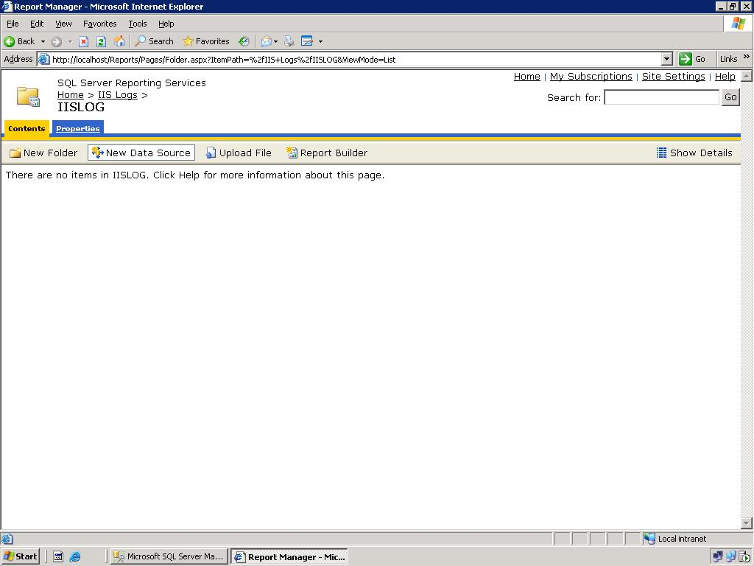
  - In Name, type IISLOG. The reports reference the data source by this name.
  - In Description, type a description or leave the field blank.
  - From Connection Type, select Microsoft SQL Server.
  - In Connection String, provide the connection string to the database that contains the IIS data. An example of the connection string for a local sample database is: data source=(local);initial catalog=IISLOG
  - Under Connect Using, select Windows NT Integrated Security or the appropriate database credentials.

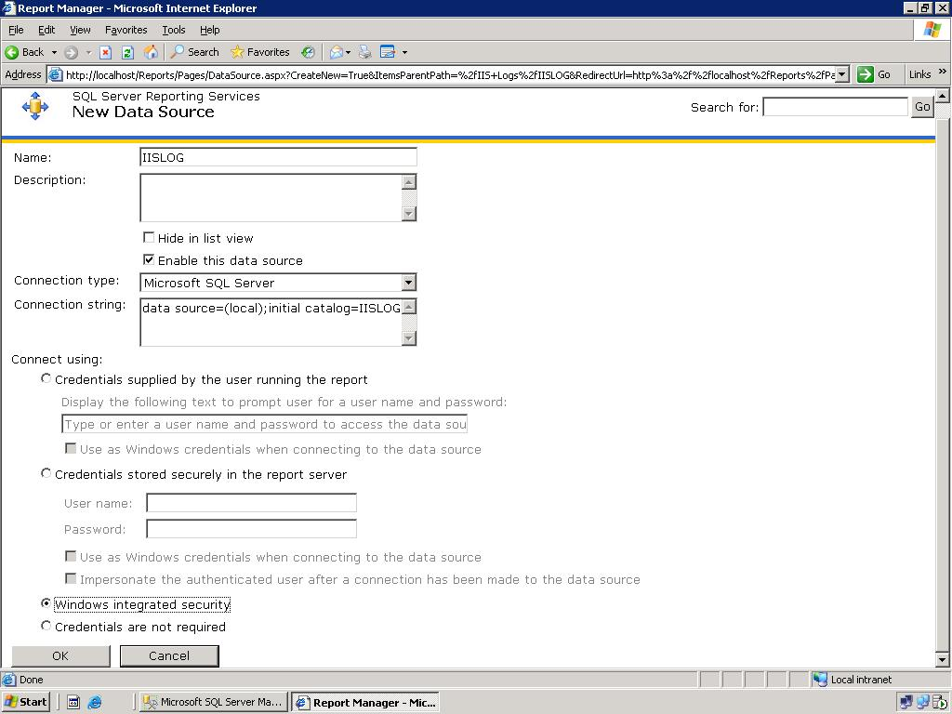

- Click OK to save the data source and return to the folder view.
- To upload the actual reports, click Upload File, and then click Browse to navigate to the directory that contains the reports.
- Click the file to upload, and then click Open.
- Click OK to open the file.

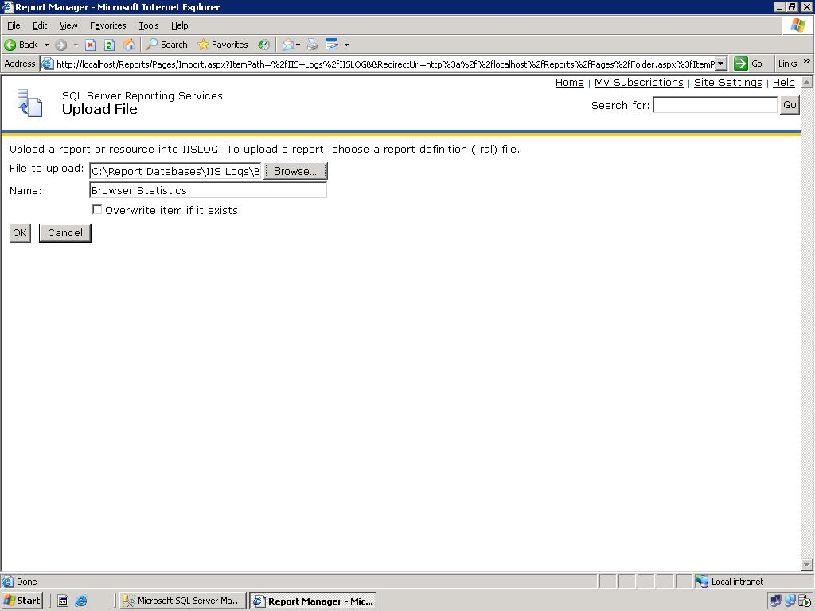

- Repeat steps 5 through 7 for the remaining sample reports.

Link reports to correct Data Source
- Click on one of the reports uploaded in the previous section.
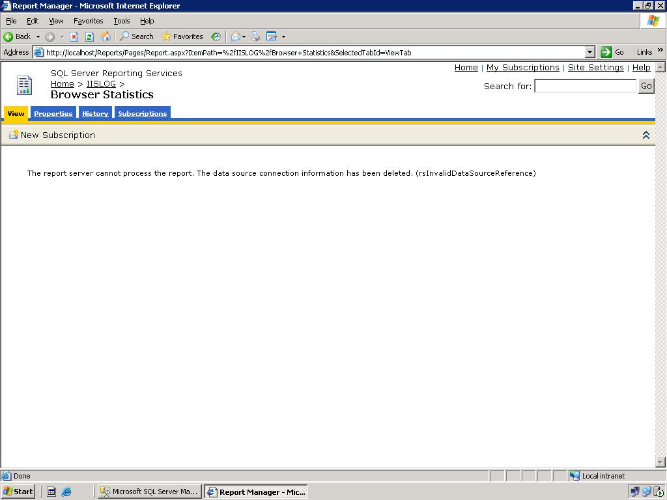

- Click on the Properties tab
- Click on Data Sources in the menu on the left
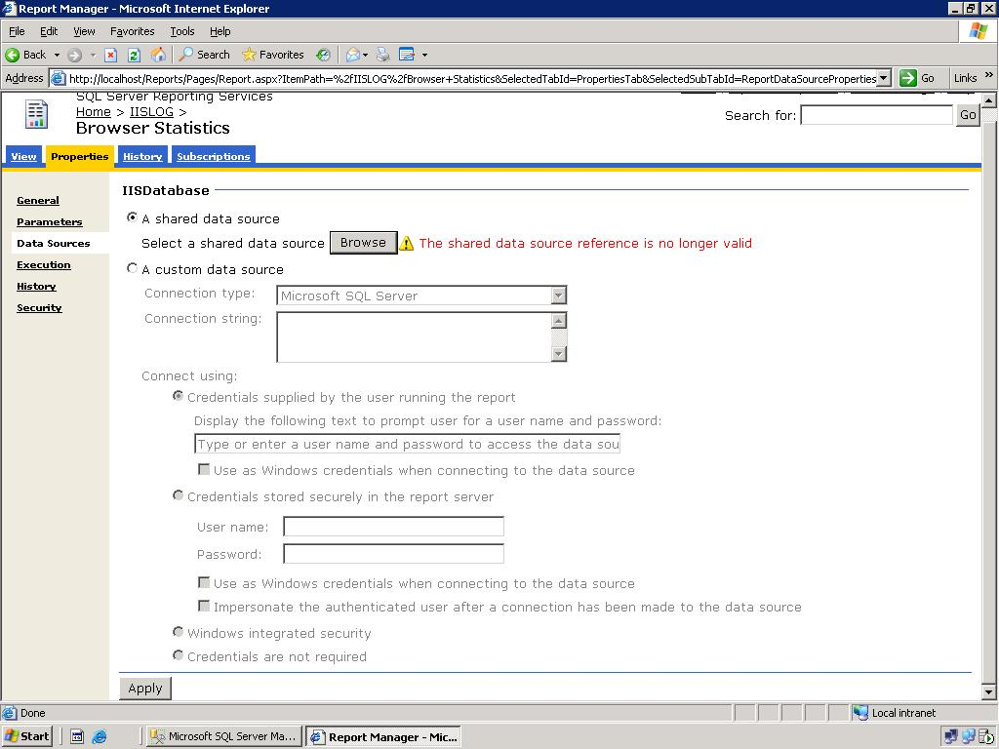

- Click Browse and navigate to the Data Source created for these reports.
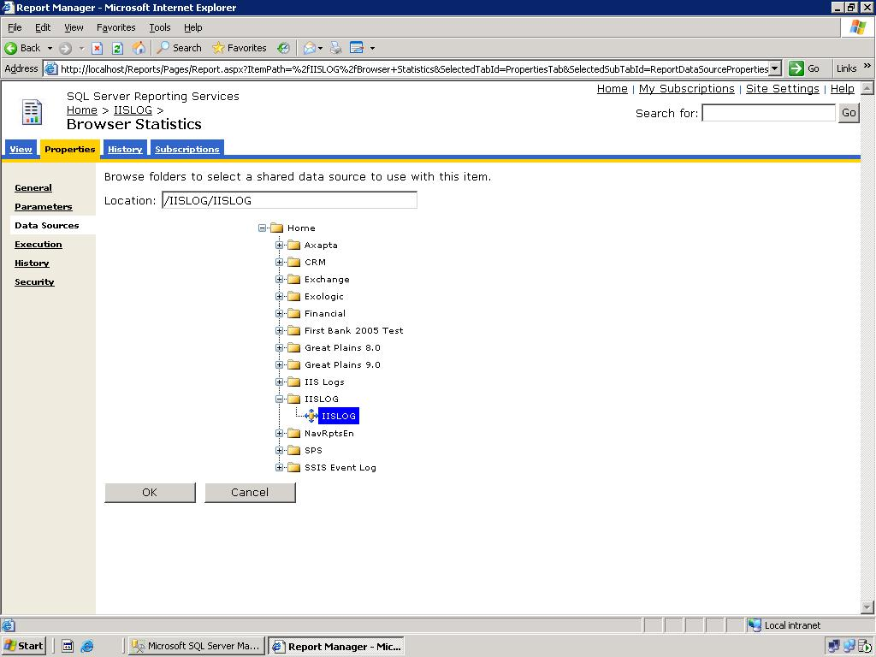
- Click OK to return to the previous screen, and click Apply at the bottom of the screen.
- Repeat steps 1 through 5 for the remaining reports.

Using the Sample Reports
You can view the sample reports in a Web browser or edit them in Report Designer. Before you run the reports, ensure that the IISLOG database is available to the reports and confirm that the user has full read access to all views and tables in that database.

View sample reports using Report Manager
- To run Report Manager, type its URL in the address bar of a Web browser. By default, the URL is http://<webservername>/reports.
- Navigate to the folder that contains the reports.
- Click the name of the report that you want to view to open it.
Edit the reports using Report Designer
- Open Visual Studio 2005, and then open the IISReports.sln file from the folder that contains the sample reports. For more information about working with reports and report projects, see Building Reports.

Loading the database with your own IIS Log Data
To load your own IIS log data into the database, you will need to download the Log Parser in the IIS Resource Kit Tools available from the IIS download page. From a command prompt, run the following command from the directory where the log parser has been installed (%ProgramFiles%\IIS Resources\Log Parser by default).
LogParser "SELECT date, time, strcat(strcat(strcat(TO_STRING(TO_TIMESTAMP(date, time), 'hh'),':00-'), TO_STRING(TO_TIMESTAMP(date, time), 'hh')),':59') AS Hour, TO_Int(TO_String(date,'MM')) as Month, TO_Int(TO_String(date,'yyyy')) as year,c-ip, cs-username, s-sitename, s-computername, s-ip, s-port, cs-method, cs-uri-stem, cs-uri-query, sc-status, sc-substatus, sc-win32-status, sc-bytes, cs-bytes, time-taken, cs-version, cs-host, cs(User-Agent), cs(Cookie), cs(Referer) FROM C:\IISLog\mylogfile.log TO GlobalIISLog" -i:IISW3C -o:SQL -server:(local) -database:IISLog -createtable:ON
By default, IIS log files are created in the %SystemRoot%\System32\LogFiles\W3SVC1 directory. In the above example, you will need to replace C:\IISLog\mylogfile.log with the path of the log file that you wish to upload. See the LogParser documentation for more information about the available command line parameters.
To be sure to have all data in the database you need to use the Internet Information Services Administrator tool to configure the format of IIS Logging for the web site to “W3C Extended Log File Format”. On the extended properties tab of the dialog, select the following fields:
- c-ip
- cs-username
- s-sitename
- s-computername
- s-ip
- s-port
- cs-method
- cs-uri-stem
- cs-uri-query
- sc-status
- sc-substatus
- sc-win32-status
- sc-bytes
- cs-bytes
- time-taken
- cs-version
- cs-host
- cs(User-Agent)
- cs(Cookie)
- cs(Referer)

More Information

Internet Information Services Web Site

Copyright
Information in this document, including URL and other Internet Web site references, is subject to change without notice. Unless otherwise noted, the example companies, organizations, products, domain names, e-mail addresses, logos, people, places, and events depicted herein are fictitious, and no association with any real company, organization, product, domain name, e-mail address, logo, person, place, or event is intended or should be inferred. Complying with all applicable copyright laws is the responsibility of the user. Without limiting the rights under copyright, no part of this document may be reproduced, stored in or introduced into a retrieval system, or transmitted in any form or by any means (electronic, mechanical, photocopying, recording, or otherwise), or for any purpose, without the express written permission of Microsoft Corporation.
Microsoft may have patents, patent applications, trademarks, copyrights, or other intellectual property rights covering subject matter in this document. Except as expressly provided in any written license agreement from Microsoft, the furnishing of this document does not give you any license to these patents, trademarks, copyrights, or other intellectual property.
© 2005 Microsoft Corporation. All rights reserved.
Microsoft, MS-DOS, Windows, Windows NT, Windows Server, and Visual Studio are either registered trademarks or trademarks of Microsoft Corporation in the United States and/or other countries.
The names of actual companies and products mentioned herein may be the trademarks of their respective owners.

